**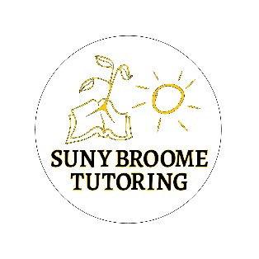**

**Learning Assistance Department**

Tutoring - Drop In - No appointment needed

**Fall 2023**

|  |  |  |
| --- | --- | --- |
| **Course** | **Days/Times** | **Location/ Tutor(s)** |
| Biology (BIO 101, 102, 117, 118, 131, 132, 150) | M 2-6,T 11-4, W 12-5,Th 12-4, F 10-2 | L 214 - Debbie//Brent/Emily/Gabe |
| BIT (all - online only) | * 1. scheduled online   dupuisjl@acad.sunybroome.edu | Jocelyn |
| Business | Accounting - T 11:30-4:30  1-1 & online as requested | L 215 - Janet  Audrey/Cassandra |
| Chemistry | M 10-6, T 9-4, W 9-5, Th 10-4, F 1-3 | L 214 - Alex/Debbie/Gabe/Lena/Ashleigh |
| Computer Science | M 1-4, W 3-5, Th 3-5 | AT 007 - Natalie |
| History | W 1-2 & R 2-3 | L 205 - Dawn |
| Math | M – Th 9-8, Fri 9-4, Sat 1-5, Sun 3-7 online | L 010- varied  <https://www2.sunybroome.edu/lad/math-lab/> |
| Nursing | M 9-11 & 12-2, T 1-2, W 2-3 & 5-6:30, TH 1-2, F 1-2 | D 211 - Brandy & Alexis |
| Physics | M 4-6, W 1-2, Th 11-12, F 1-3 | L 214- Alex & Sean |
| PTA | F 10-2  T 6- 8 online | L 214 - Emily  <https://zoom.us/j/93157727729?pwd=M0JVMWdFcUdSb1JvdWZkU3dPQlJoZz09> |
| RAD | M & W 4-5 | D 313 - Tom |

**Location Directory**

**\*AT 007** – Computer lab in Applied Technology Building

**\*D118, D211, D 313** –Decker Classroom

\***L 214, L205, L215** - Upstairs, top floor of the Library

**\*L 010** , first floor of the Library

**Online** individual utoring support via STAR NY: Sun-Thur 7 pm to midnight:

[https://www.starny.org/tutoring\_schedule](https://www.starny.org/tutoring_schedule" \t "_blank)

Questions? Email paniccialm@sunybroome.edu or call (607) 778-5162